1. Taller
   1. https://youtu.be/49fADBfcDD4
2. Datos

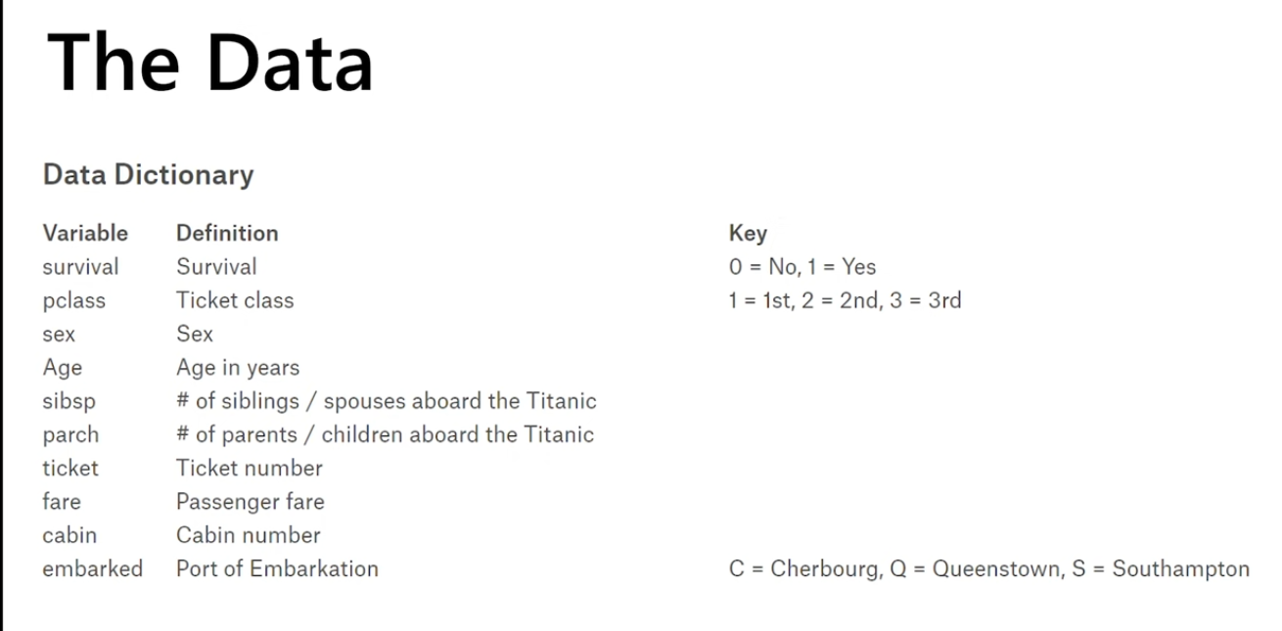

1. Escenario

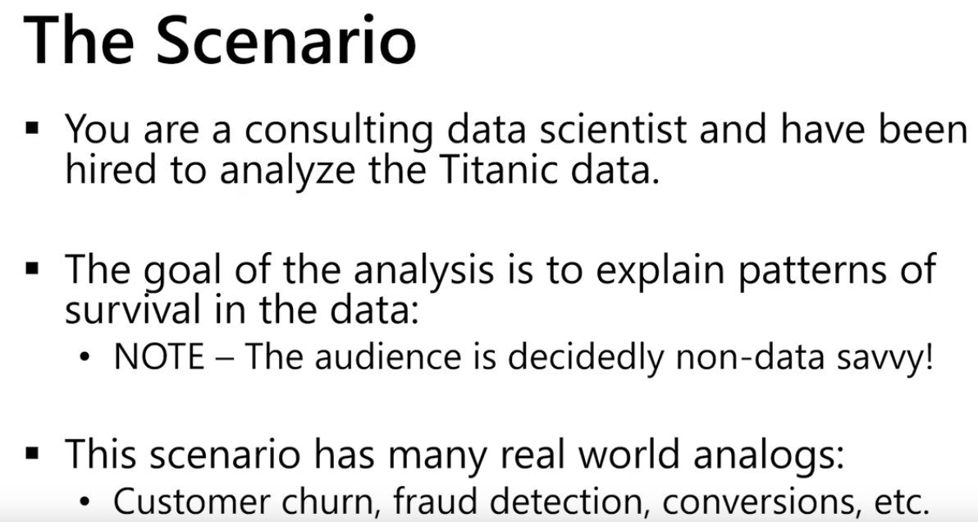

1. The gramar of ggplot

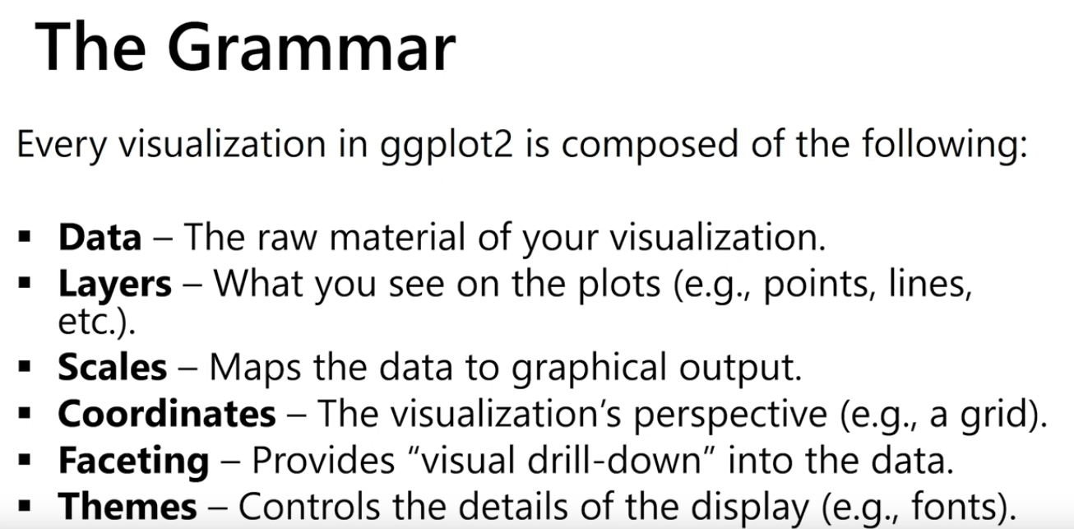

1. Most of the time, you just need:

